SUPERFIT- PECS

3 SETS of EACH EXERCISE
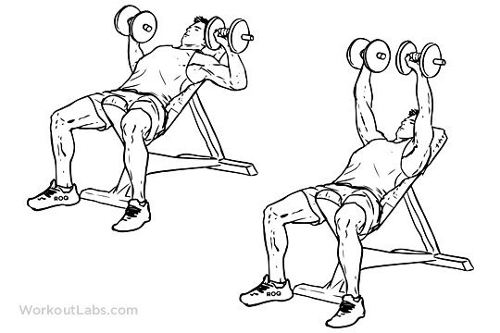
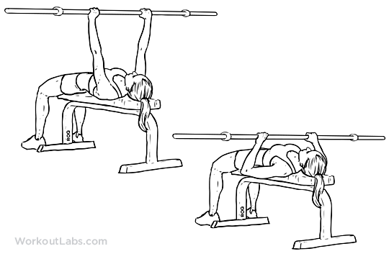

- FLAT BENCH – Barbell

- INCLINE BENCH – Dumbbells
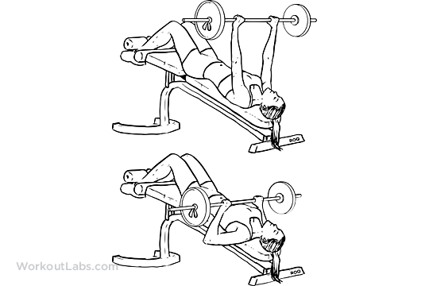
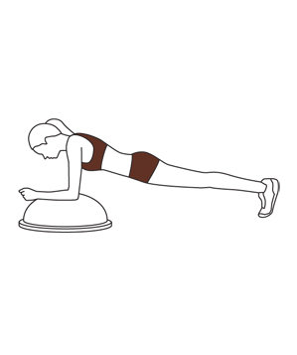
- DECLINE BENCH – Barbell

- BOSU – Plank
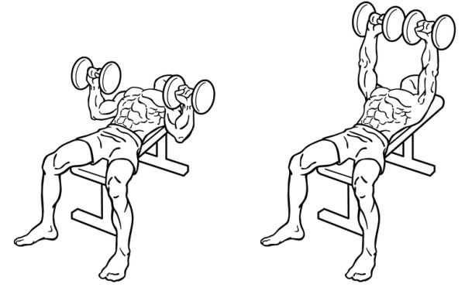
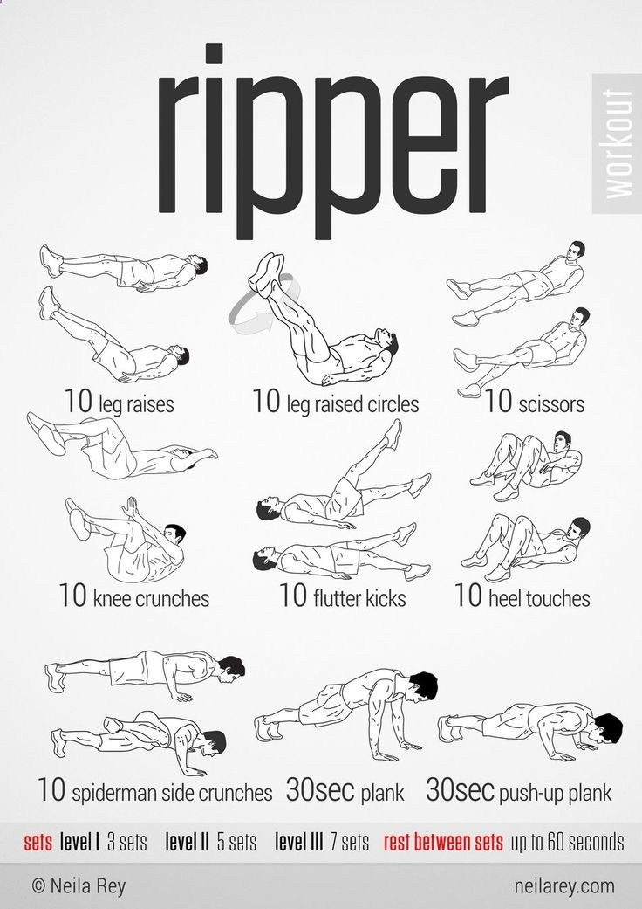
- PORTABLE BENCH – Dumbbells

- AB RIPPER

- PORTABLE BENCH - Flys

- PUSH-UPS - Handles or Dumbbells

- CORE - Heavy Ball on BIG Ball

- LYING BOX - Dumbell Hammer Press
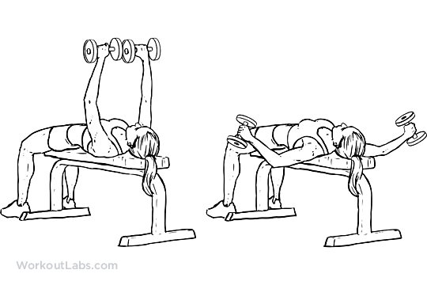

- PEC DEC – Station
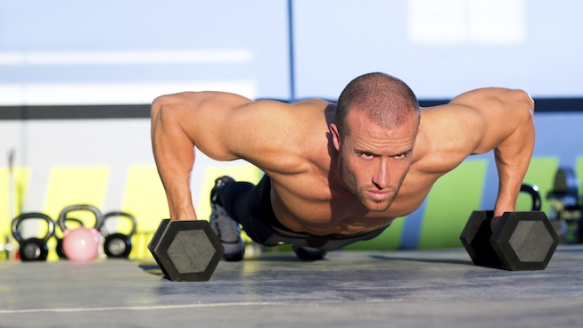

- CABLE CROSSOVERS – Station
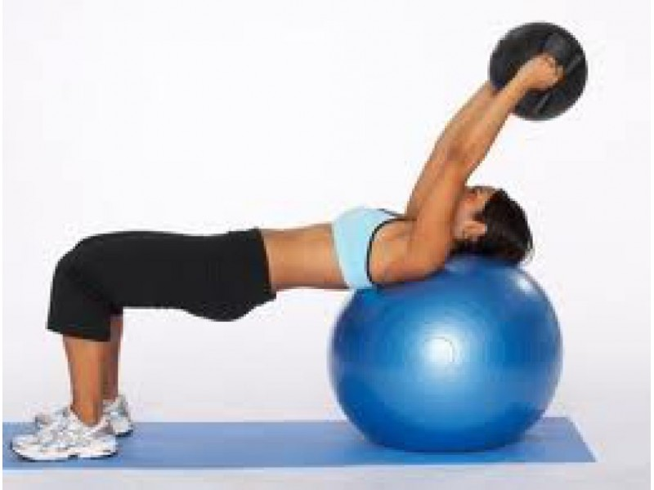

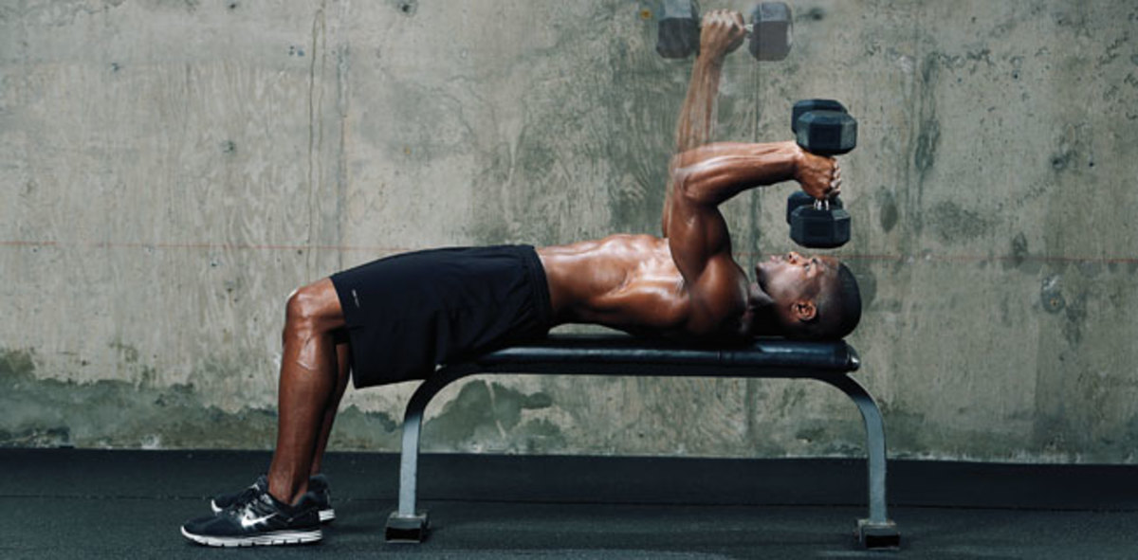
SUPERFIT - LEGS

3 SETS of EACH EXERCISE
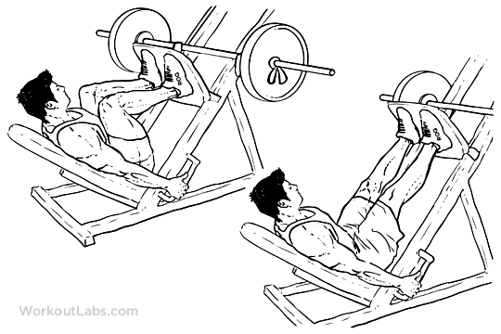
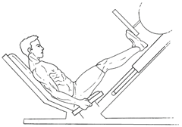
- LEG PRESS

- CALF PRESS
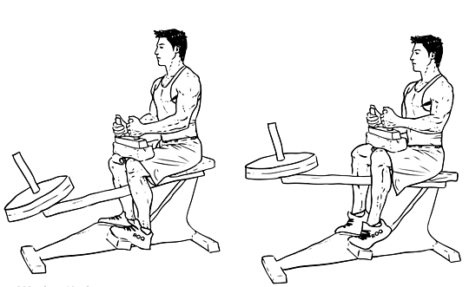

- SEATED CALF MACHINE
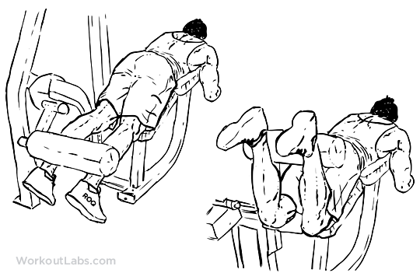
- LEG CURL
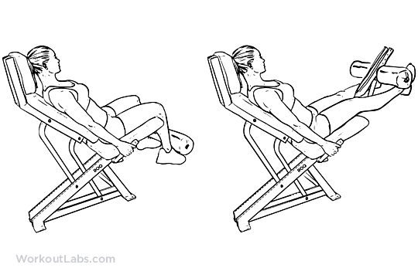

- LEG EXTENSION
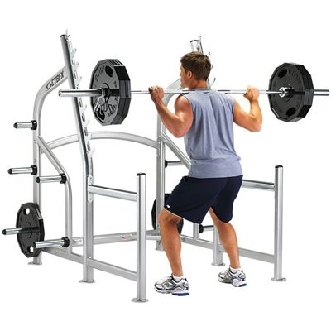
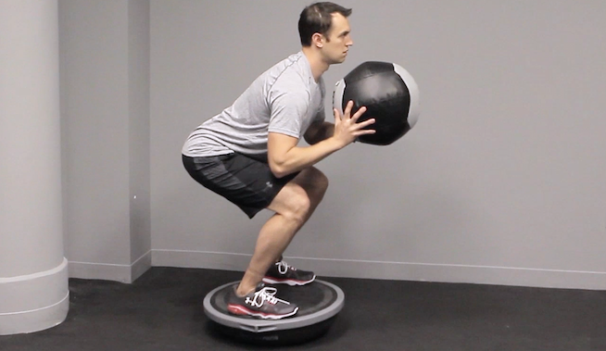
- SQUAT RACK
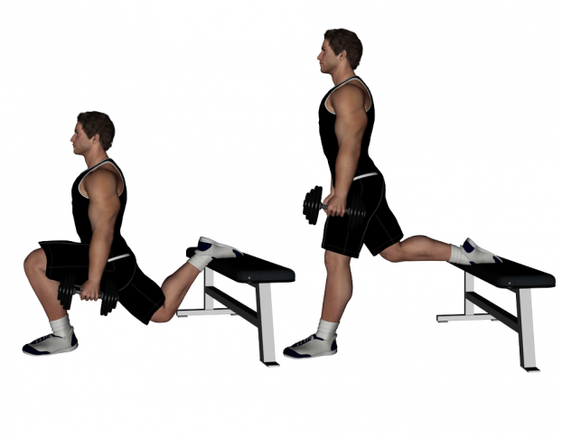
- BOSU CORE HEAVY BALL SQUATS

- PORTABLE BENCH 1 LEGS SQUAT JUMPS

- 2 BOSU SIDE 2 SIDE AGILITY JUMPS
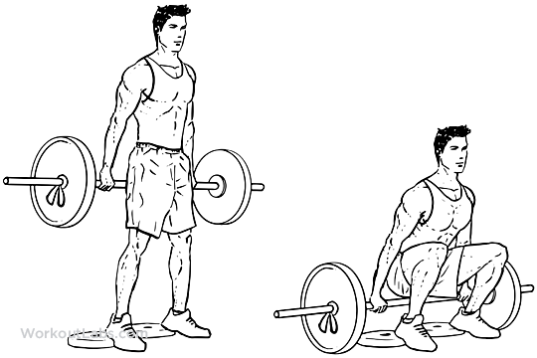
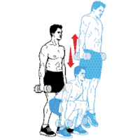
- HACK SQUATS

- DUMBELLS JUMPS
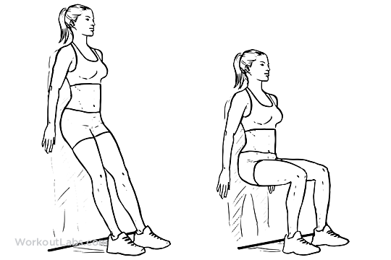

- WALL SIT SQUAT SIT

- SPIN BIKES - 30 sec. on – 1 min. recovery SPRINTS
- LEG STRETCHES
SUPERFIT - ARMS

3 SETS of EACH EXERCISE

- BICEP CURLS - Standing CURL BAR

- BICEP CURL – Standing on BOSU with DUMBELLS

- TRICEP SKULL KRUSHERS - short straight bar

- TRICEP KICKBACKS – Standing with Dumbells

- FOREARM WRIST CURLS - Bench under lower forearms

- FOREARM ROLLERS – Standing Dumbell Progression

- BICEP CURLS – 4 and 4 - one arm stays at 90’ for 4 reps

- BICEP CURLS on BOSU one leg Skating leg recovery repeats

- TRICEP Seated single DUMBELL Press

- TRICEP Rope Pulldown – Station

- FOREARMS - Wrist roller with rope and weight plate

- FOREARMS – Reverse Hammer Curls - Curl or Straight Bar

- TRICEP Bench Lying down - Dumbell Press

SuperFit -Back/Shoulders
3 SETS of EACH EXERCISE

- Lat Pulldown – Wide Grip – Front - Vertical body position
- Lat pulldown – Wide Grip – Front – Angled Body Tilt

- Shoulder – Bent Arm Dumbell Flys
- Shoulder - Straight Arm Front and Side Alternate Raise

- Lats – Chin-ups Narrow Grip- Palms face body
- Lats – Chin-ups Wide Grip – Palms face out away from body

- Shoulders 21’s - 7 Flys, 7 Press, 7 Arcs = 21

- Seated Row Cable station – Narrow handle
- Seated Row Cable station – Wide handle

- Bent Over One Arm Dumbell bench rows
- Lying face down -Two Arm Dumbell bench row

- Deadlift – Standing Opposite Grip – Olympic Barbell
- Deadlift finisher move heavier – Squat rack

- Core – Knee lift Station – Bent Knees or straight legs
- Core- Arm Slings –Bent Knees (Center Left Center Right)

- Kettlebell – Bench seat touch Front one arm Raise Core Hip

- Short Bars– Standing – Bent over Rows

