How To Access Your School District 67 Email From Home

From A Computer:

- Go to School District 67 Website: http://www.sd67.bc.ca

- Click on Web Mail at the top of the page

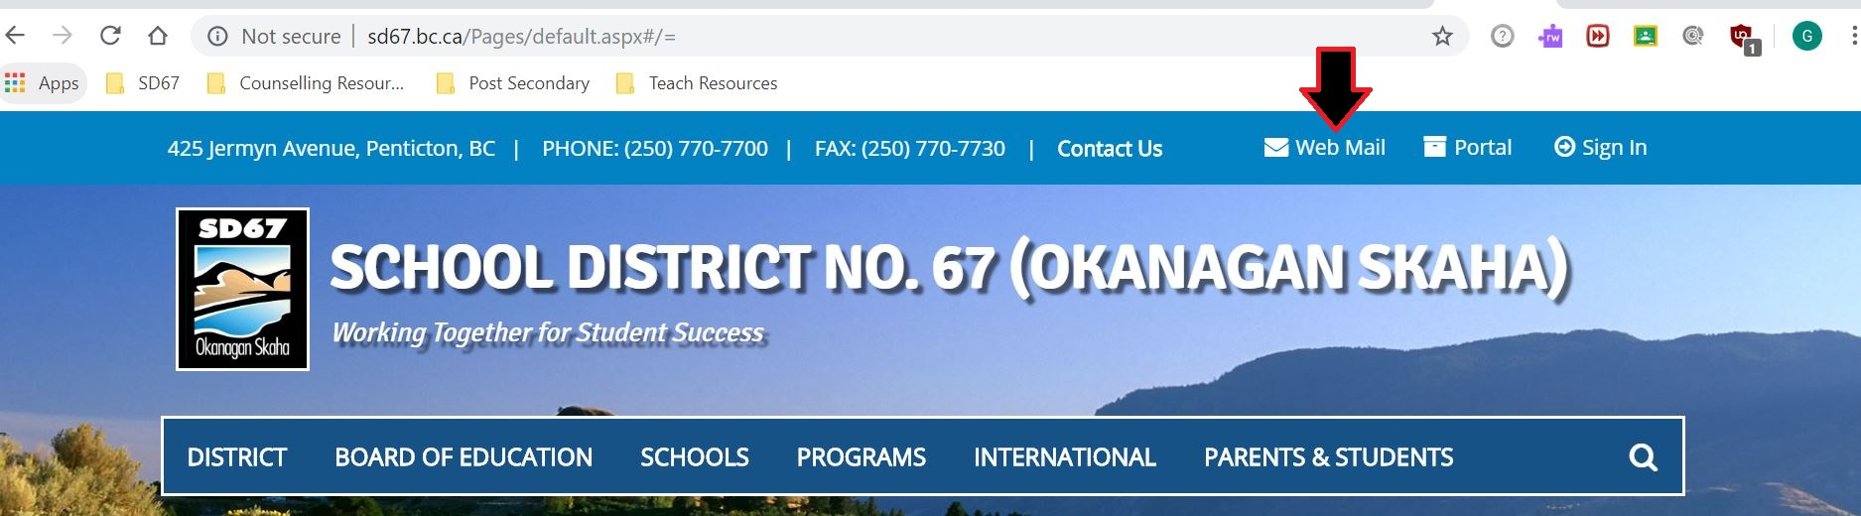

- It will open to a login page, like the one below:

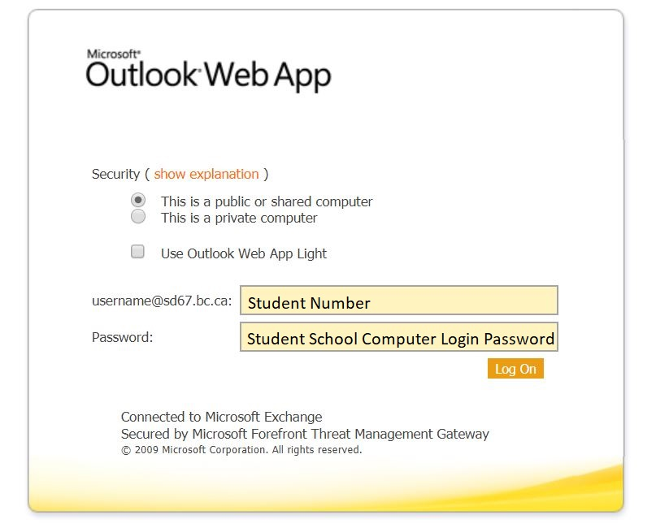
- Username: student number

- Password: the password the student uses to login to computers at the school

From A Phone:

- Go to School District 67 Website: http://www.sd67.bc.ca
- Go to Utility Links at the bottom of the page

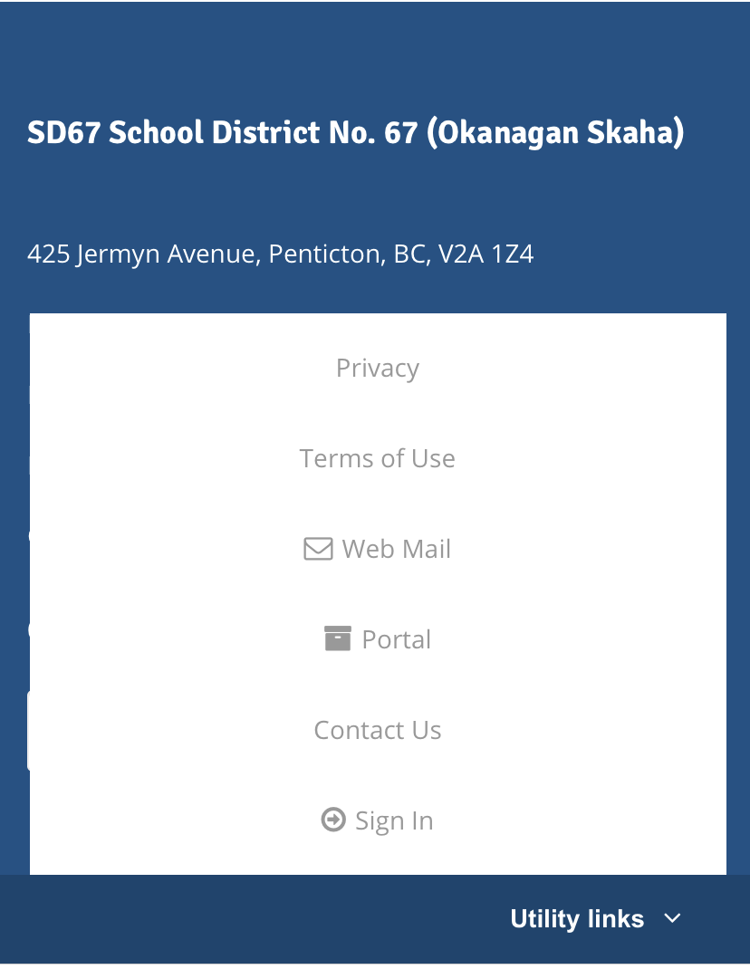

- Click on Web Mail

- Username: student number

- Password: the password the student uses to login to computers at the school

