Volleyball Class – Assignments for Course Completion
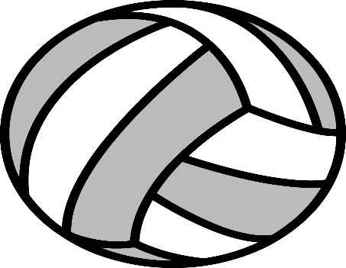
This Photo by Unknown Author is licensed under CC BY-NC
Task 1. Research and list the Key Points for 5 SKILL TECHNIQUES that you feel will improve your personal skill sets. Research 3 DRILLS for your skill ability level that you can practice individually or with help at home or at a beach court when that option becomes available.

Task 2. Create a Volleyball Journal for reflection of your development – written or video format.

Task 3. Include a personal exercise program that can be completed at home or outdoors.

Task 4. Keep a record of your skill development and personal workouts…date, time length, focus.

Task 5. Research skill drills posted on Youtube and watch a minimum of 5 top collegiate or international matches of your choice

